**DATA ANALYTICS ASSIGNMENT 1**

V. Ankitha

VNITSW

4th B.Tech (CSE)

20NN1A05I3

**BAR CHART**

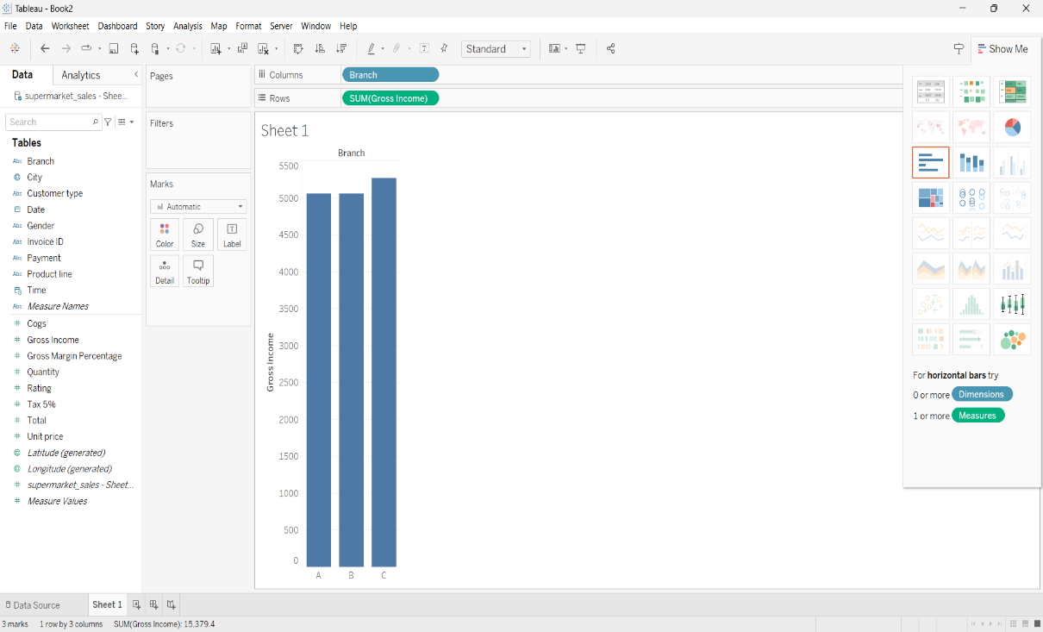

**PIE CHART**

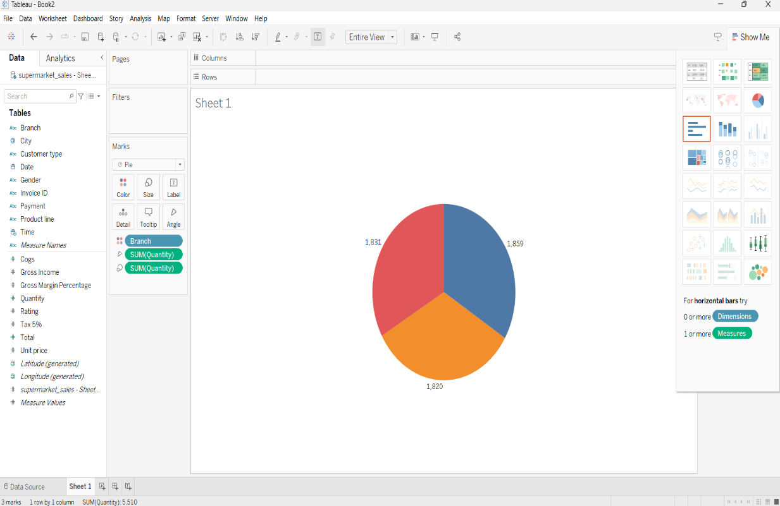

**STACKED BAR CHART**

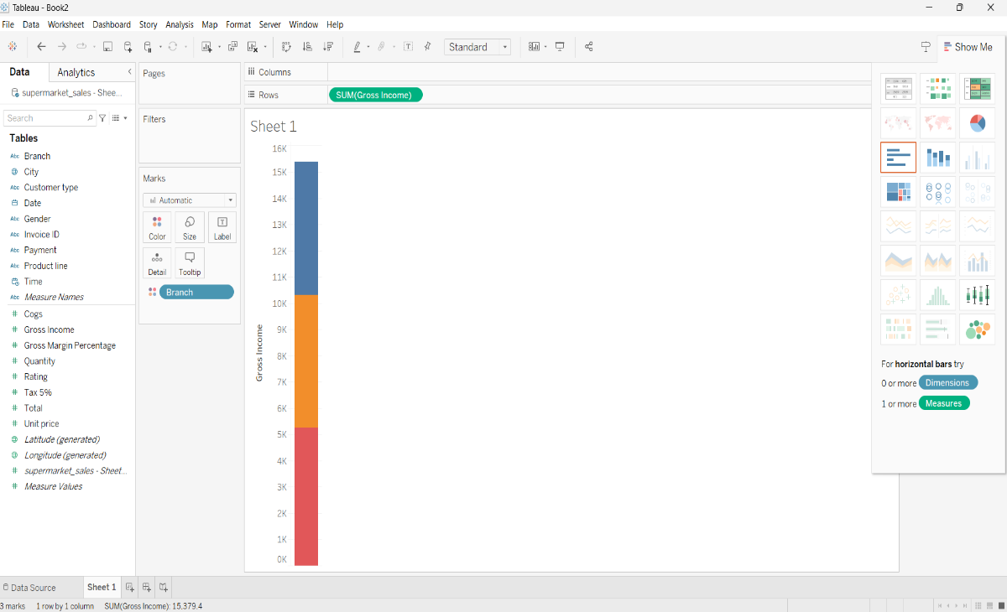

**LINE CHART**

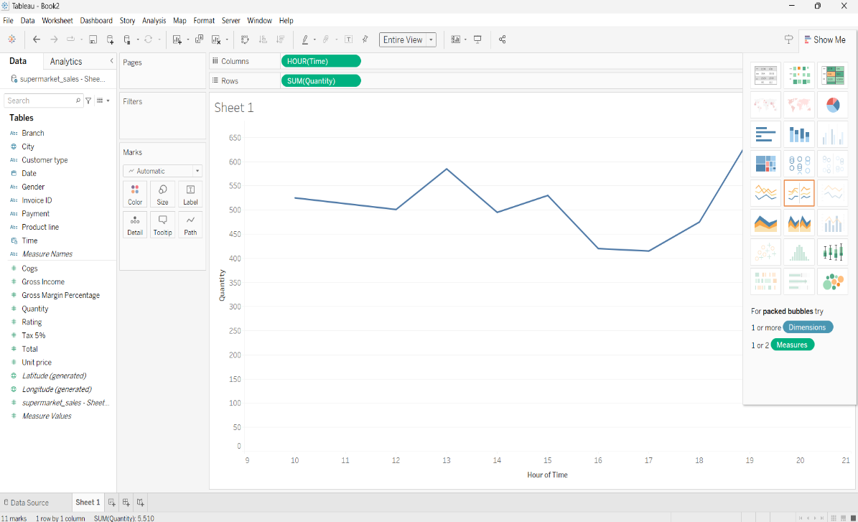

**BUBBLE CHART**

